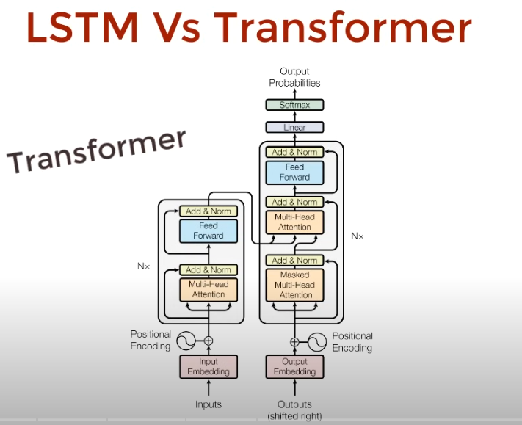 - early model for neural machine translation

In artificial intelligence (AI), LSTM (Long Short-Term Memory) is a special kind of neural network that helps computers understand sequences—meaning things that happen in order, like words in a sentence, spoken sounds, or numbers over time.wikipedia+3

What Is LSTM Used for in AI?
- LSTM helps machines “remember” important details for a long time as they look at a sequence, while also “forgetting” things that aren’t needed. This makes them much better than older models (RNNs) at dealing with long sentences, time-based data, or patterns.h2o+1
- In AI, LSTM is used for:
  - Speech recognition: Converting spoken words to text.appliedaicourse+1
  - Language translation: Translating text from one language to another.geeksforgeeks+1
  - Time series forecasting: Predicting things like the weather, stocks, or sales in the future.appliedaicourse+1
  - Text analysis: Summarizing text, detecting sentiment, or sorting messages.mathworks+1
  - Video and audio analysis: Understanding actions or sounds over time.developer.nvidia+1
  - Many other sequence-based tasks in finance, healthcare, robotics, etc.wikipedia+1

How Does LSTM Help in AI?
- LSTM’s design includes special gates to control what to remember, what to forget, and what information to use at each step in a sequence.
- This makes AI applications smarter—it can learn context, patterns, and relationships that take place over long periods and use them for predictions, understanding, or automation.iterate+2

In short:
LSTM is a powerful AI model that “remembers” and “forgets” like a human, making it possible for artificial intelligence systems to handle complex tasks that involve sequential data—speech, text, time, video, and more—much more effectively than regular neural networks.h2o+2
- https://en.wikipedia.org/wiki/Long_short-term_memory
- https://www.geeksforgeeks.org/deep-learning/deep-learning-introduction-to-long-short-term-memory/
- https://www.appliedaicourse.com/blog/lstm-in-machine-learning/
- https://h2o.ai/wiki/long-short-term-memory/
- https://www.iterate.ai/ai-glossary/what-is-long-short-term-memory-lstm
- https://developer.nvidia.com/discover/lstm
- https://www.cloudthat.com/resources/blog/long-short-term-memory-lstm-networks-in-ai-and-machine-learning
- https://www.mathworks.com/discovery/lstm.html
- https://www.simplilearn.com/tutorials/artificial-intelligence-tutorial/lstm

https://www.youtube.com/watch?v=xI0HHN5XKDo – VVV IMP

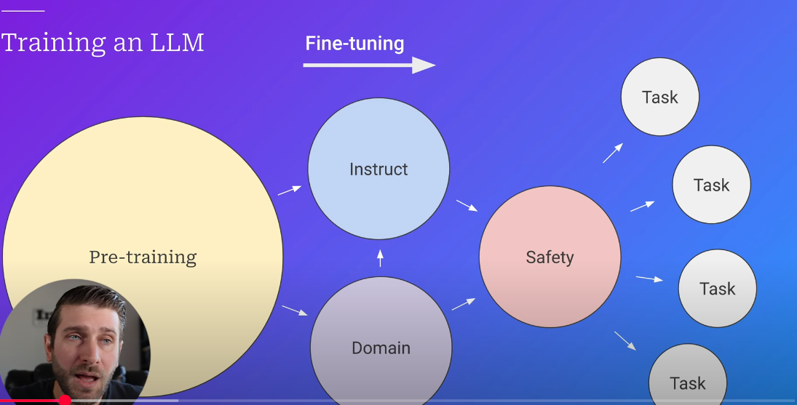

pre - training is basically having 3 trillion tokens and then training on that basis, after that It is fine tuning to perform specific tasks

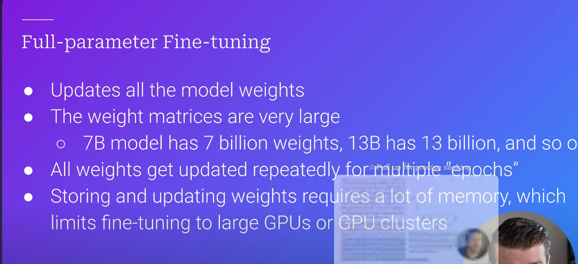 - hardware are constrains
+++ LORA solves this problem
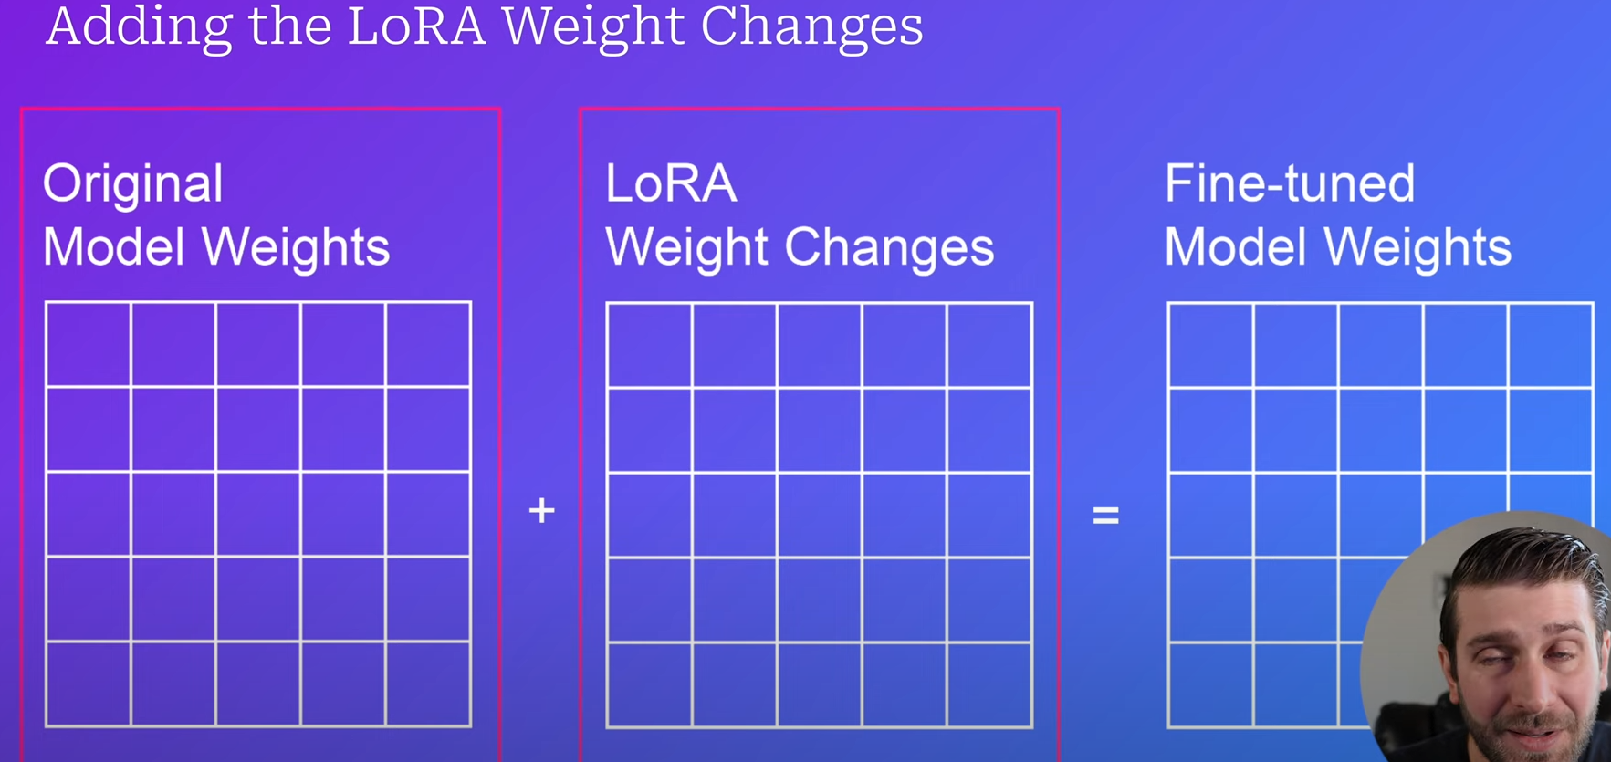
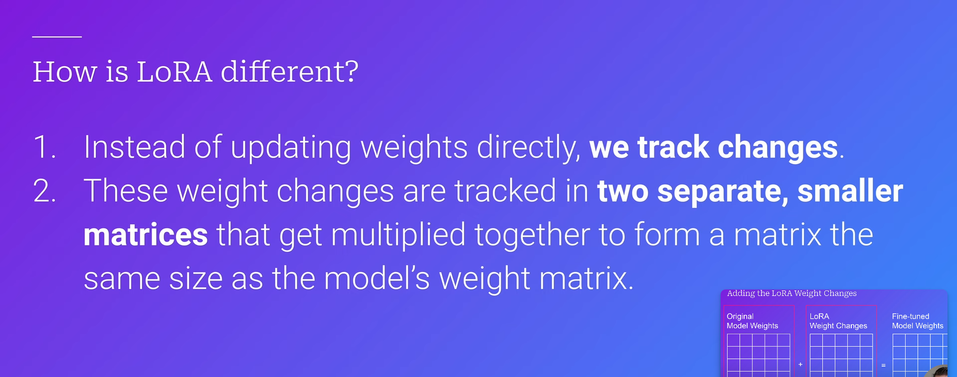

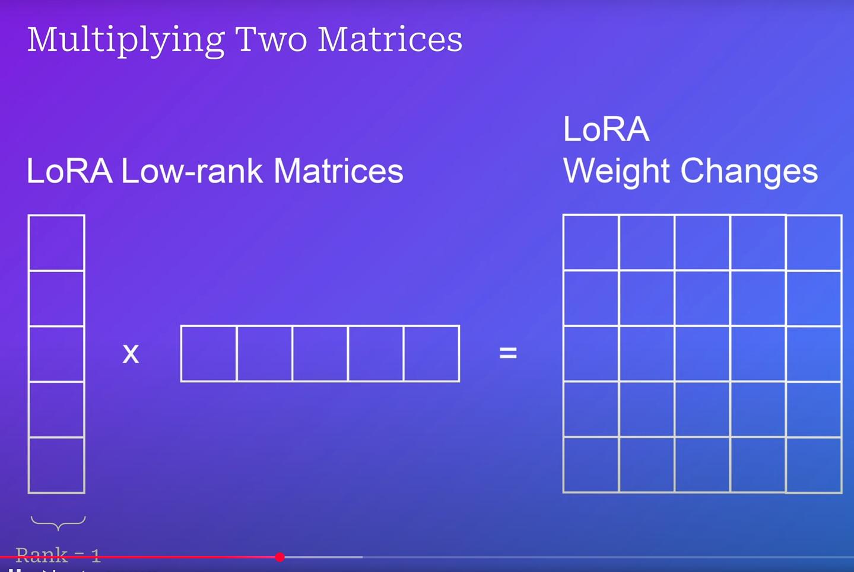 -some precision is lost – huge beneficial in efficiency as we progress
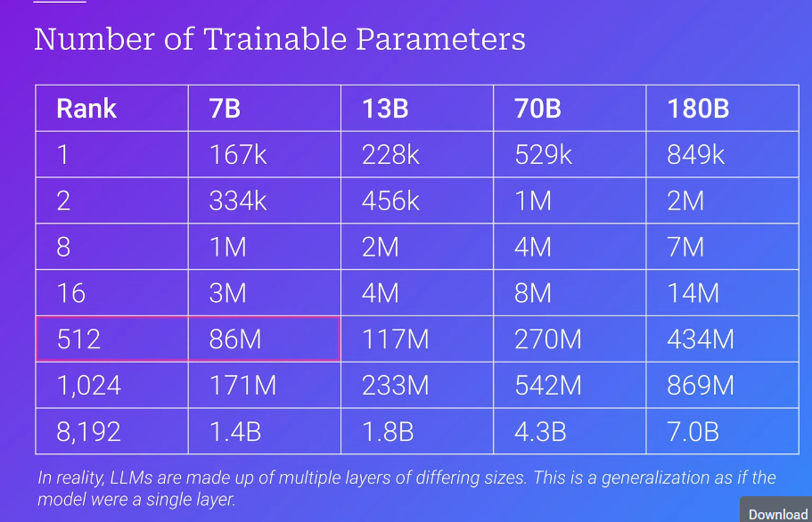
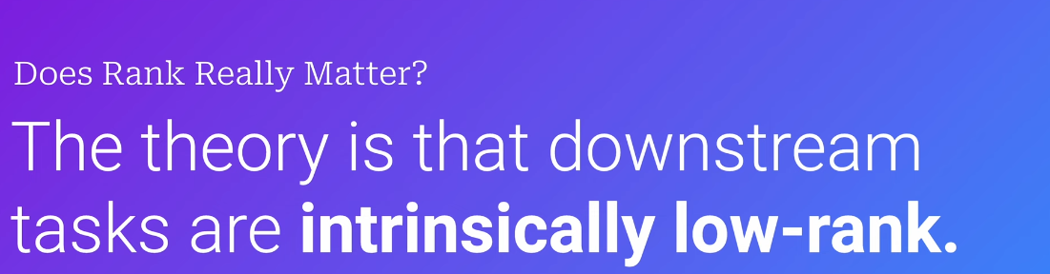

Qlora – quantized lora.
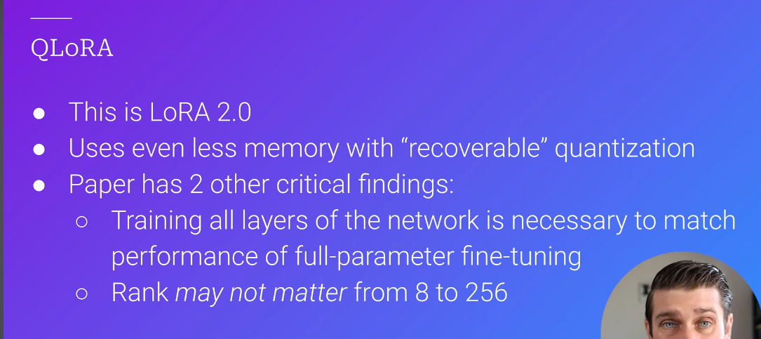

 - training would have 2x impact – coinciding with learning rate and the skill factor

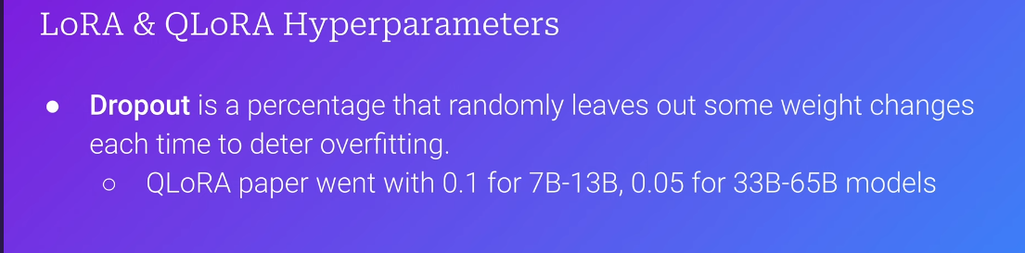

Ways to optimize AI models::
- RAG(Retrieveal augumented generation): agent can go and perform a search for the data - and then it can incorporate the data back into its answer/model –
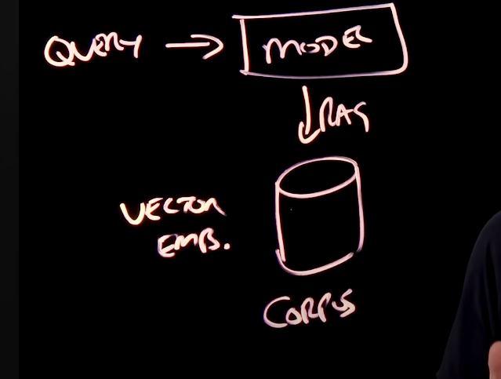 - the model will find shit that is mathematical similar to the query – using vector embeddings – and once it finds the info, it adds it to the query – incorporation of facts and figures

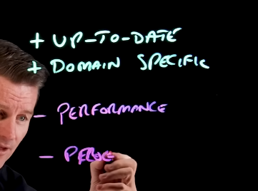

We need to store vector embeddings in a database, we also need to store the corpus amount of data somewhere

- Fine tuning : on a particular task
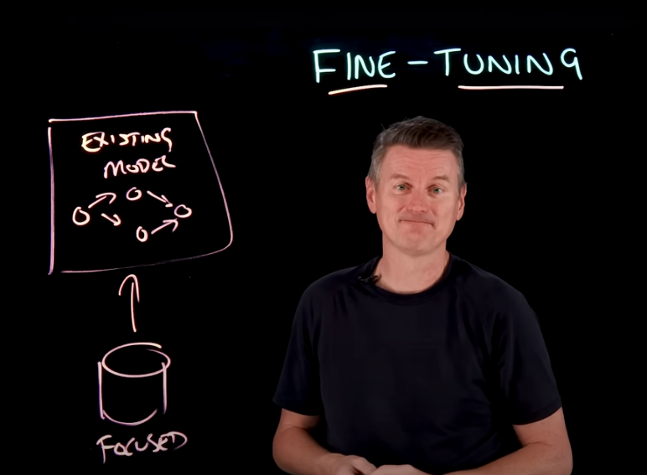 - the original existing model’s linking and relationships are changed accordingly to the fine tuning parameters that are added to it – model specifies how to learn domain specific patterns

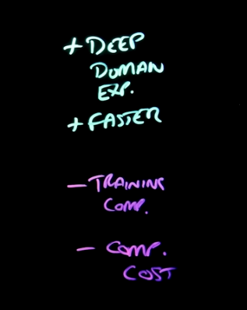 - high complexity, computational cost, maintaentance – fine tune models needs to be highly specialized training.

CATASTROPIHIC TRAINIGN -model loses some of its general training while fine tuning for a particular dataset
- Prompt engg – specifying what the model exactly is supposed to point at.
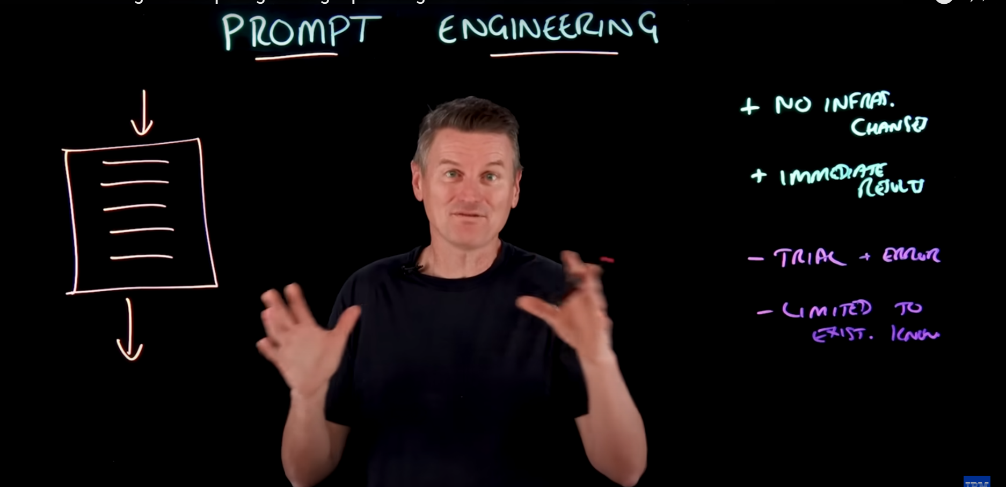 - you cant really add more new information to prompt engg

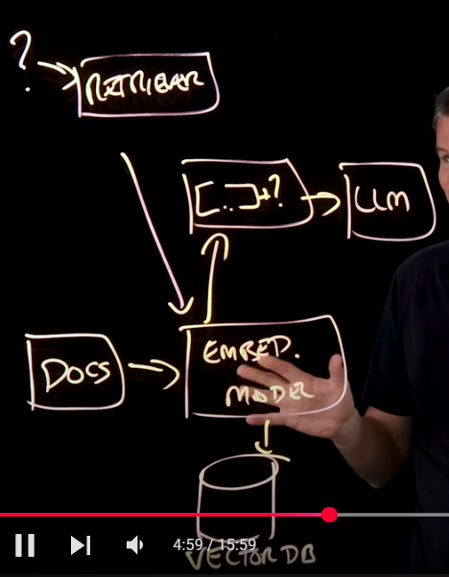 - full RAG MODELS – you can interchange it accordingly,

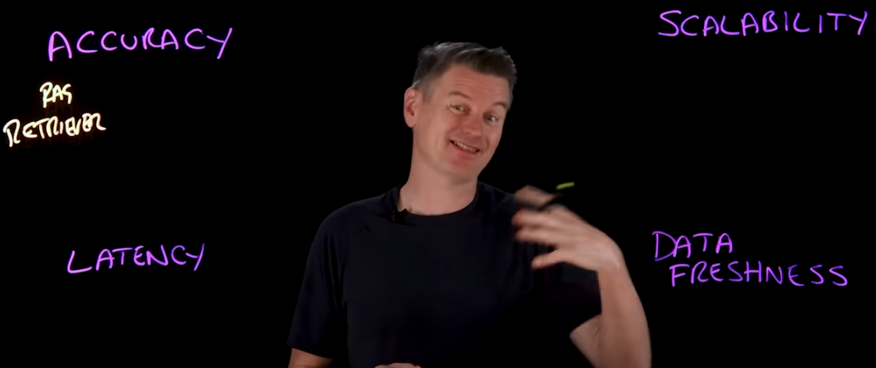 - parameters accordingly.

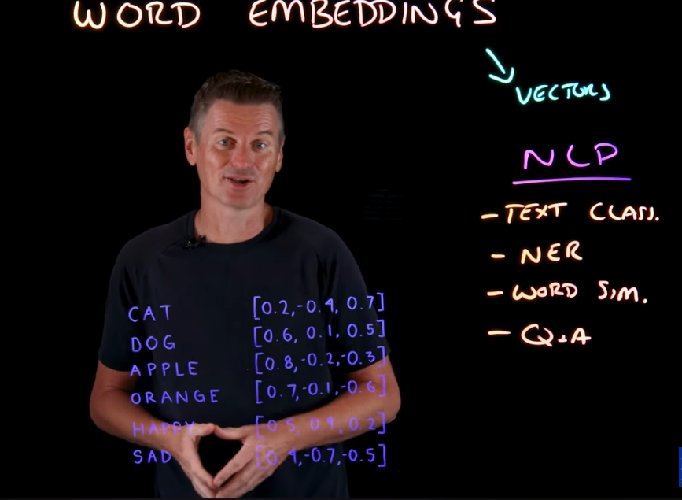 - the distance between these vector embeddings is different based on the meaning of these words

TF-IDF – “the’, and “an” – low score

Prediction based – learns the semantics and associates things and entities

Word2vec – CBOW and SKIP-GRAM
GLOVE

Contextual based embeddings change the meaning of the words represenint the context of the words.

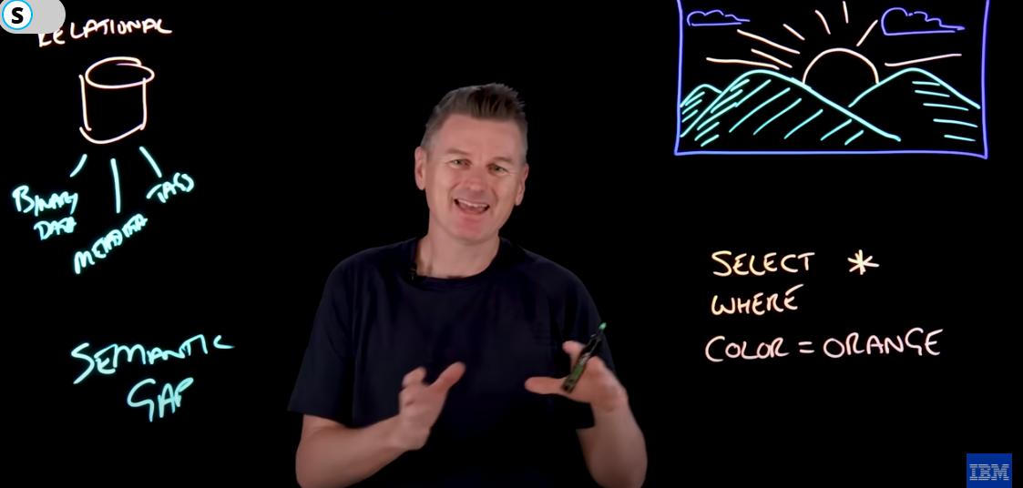 - traditional relational data has this semantic gap where we want to make our data feel valid – have the little little tags, same art style,etc to the data for similar types of data retrieval – vector embeddings capture the semantics of the database – what all do you have similar to it.

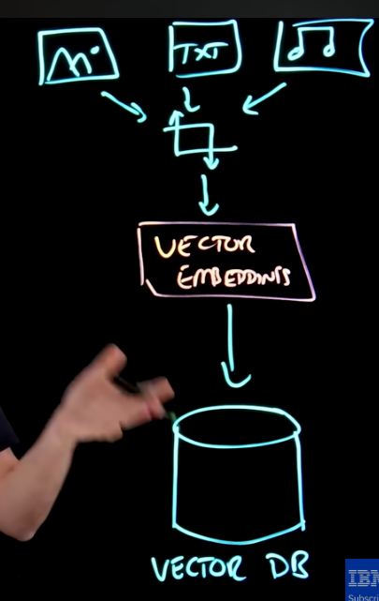

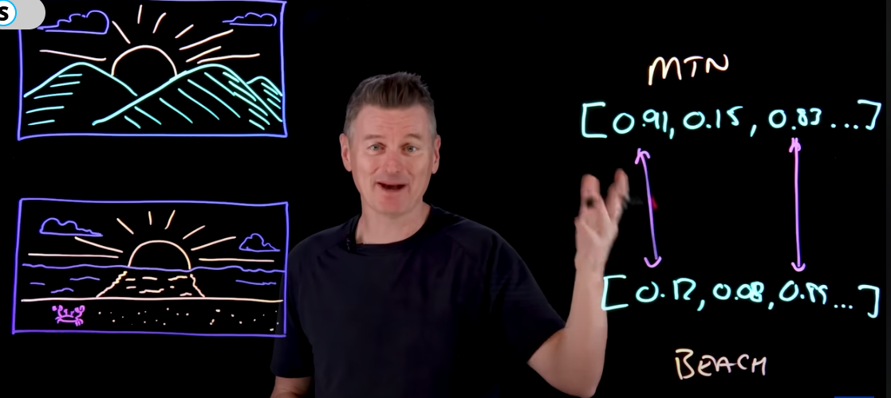 - you need to realize that the first element of the vector

Each dimension of the vector is basically based on the fact of how confident it is using thigs
Alexnet examples – no one would believe – 2030 – AI is going to take up jobs 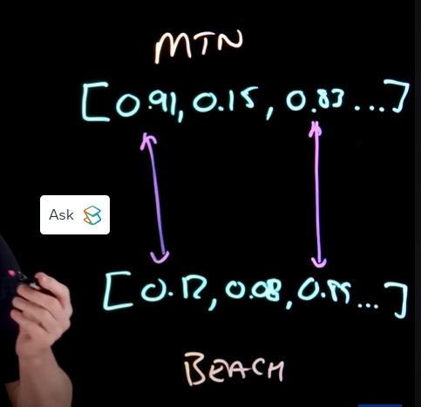 - warm colours representation – and elevation confidence competition.

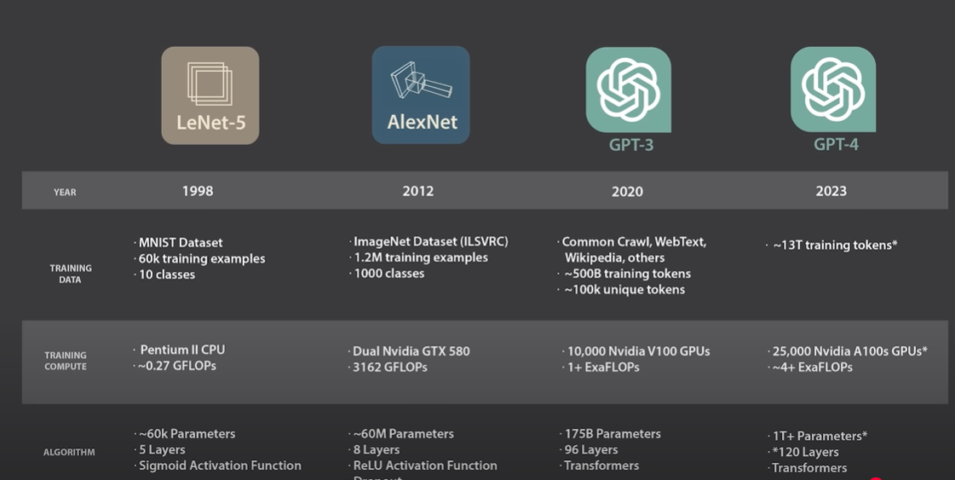

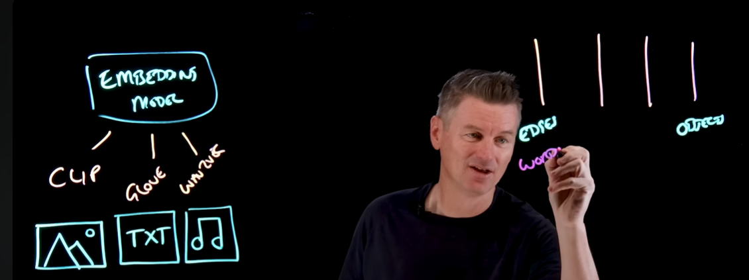 - it just passes again and again through these vector embeddings screenigns – the dimensions are lot – high in number-

 - approximat nearest neighbour
IVF – inverted flexing

RAG model – imp feature of the vector embeddings

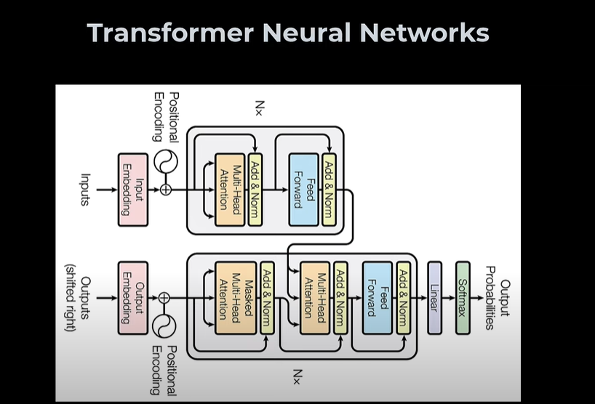

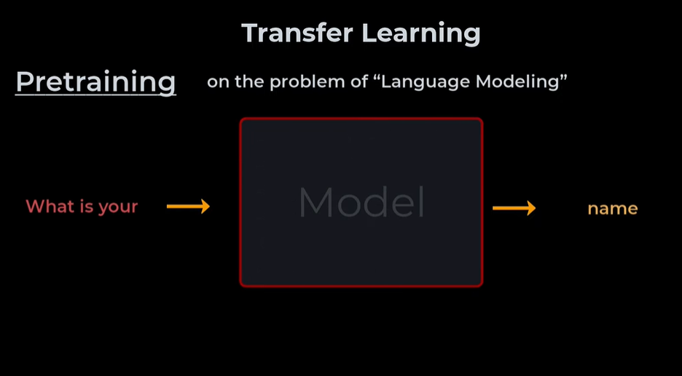
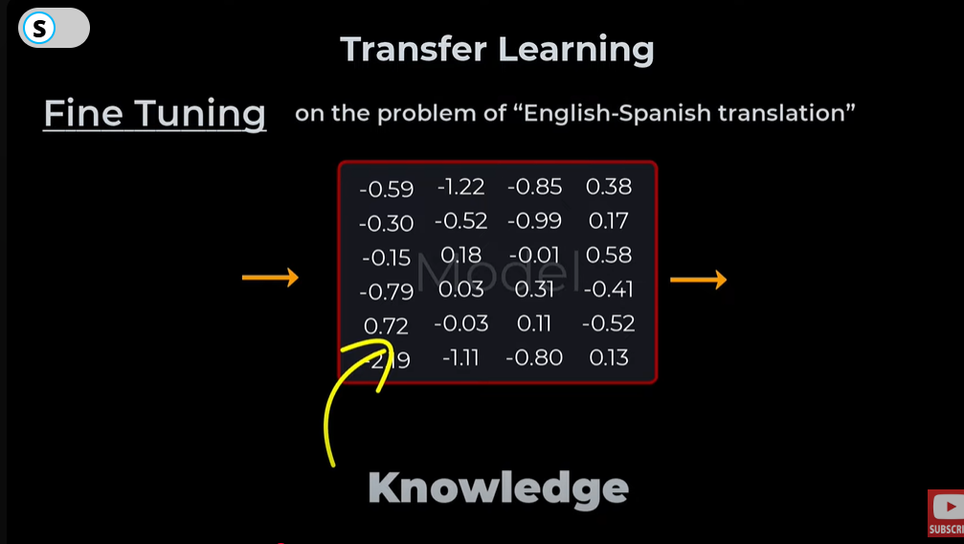
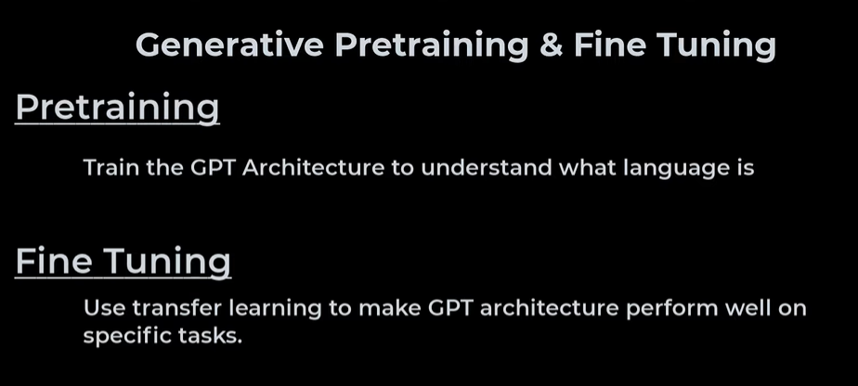

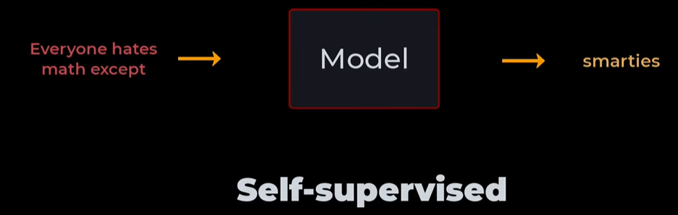 - sentences forms the task and then auto complete it accordingly.
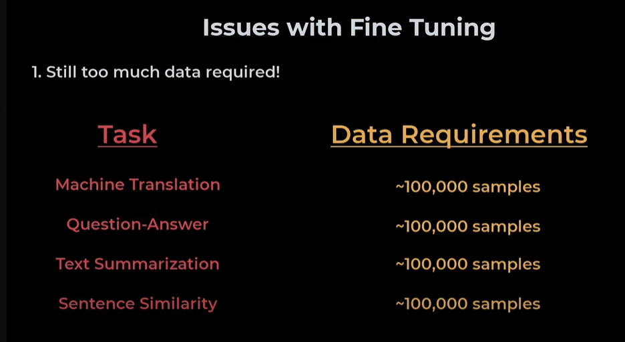

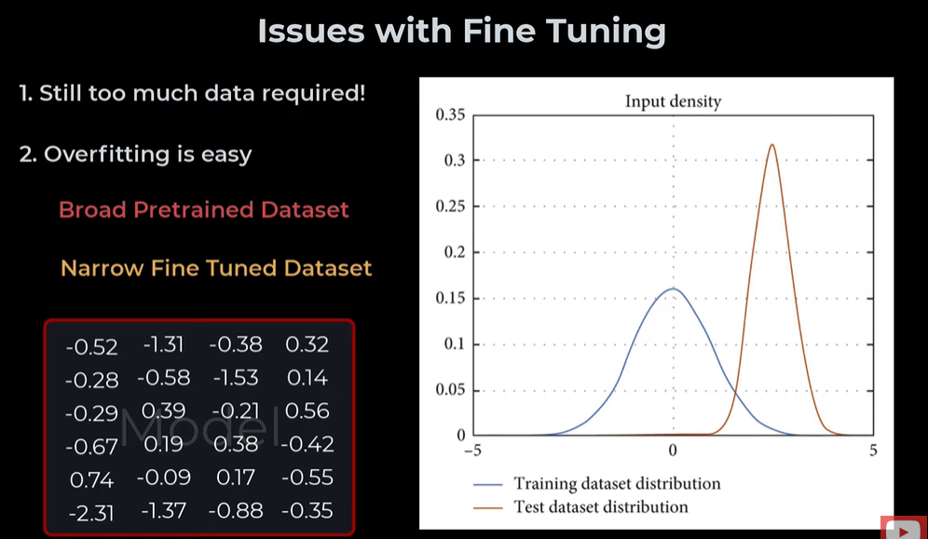 - fine tuned dataset needs to be good to be represented in the wild.
language needs to be learning according to the following this:
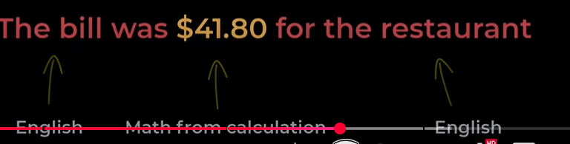

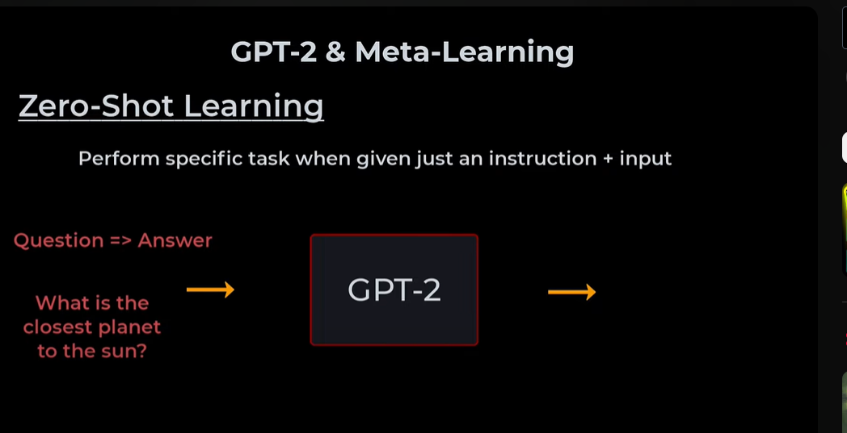 - zero shot learning – requires the model to allow a label provided to the question – answer format being asked for the same

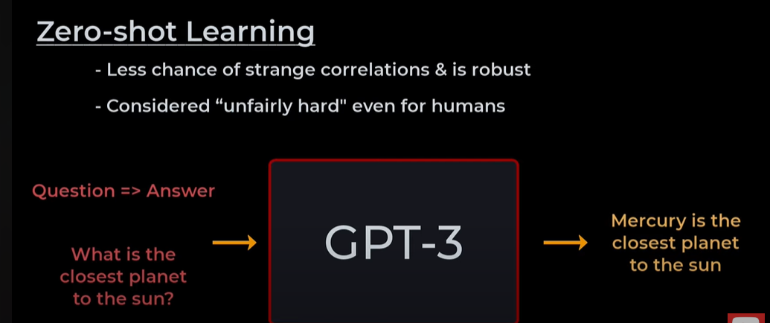 - less chances of misguided

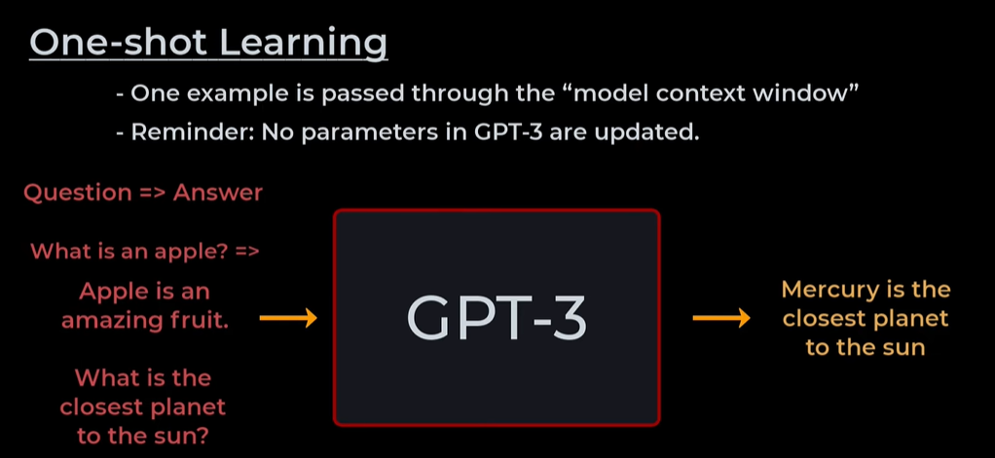

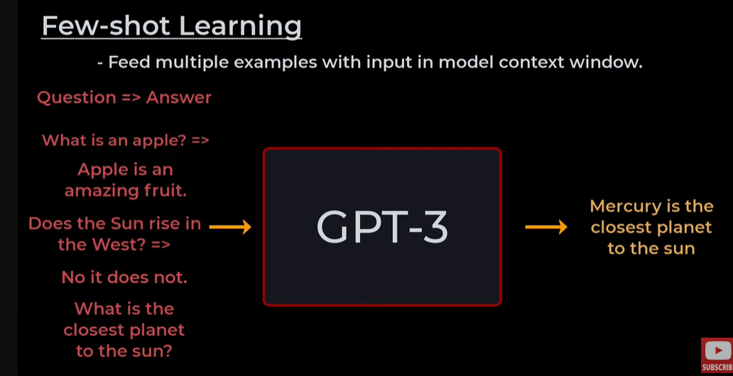 - multiple examples are learned out,

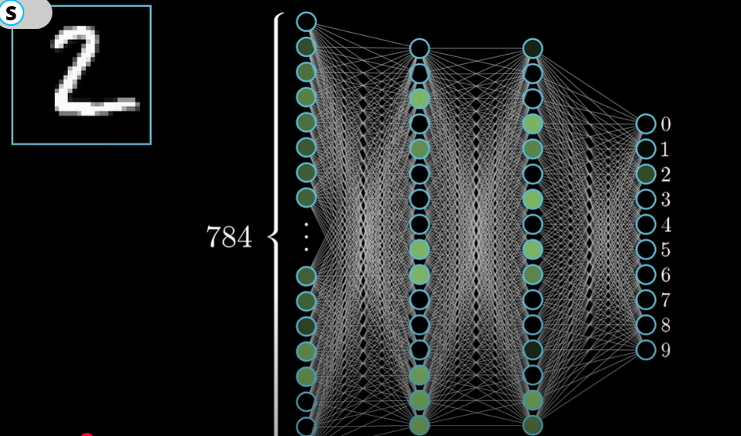 - chatgpt and varaitions - plain vanilla requirements

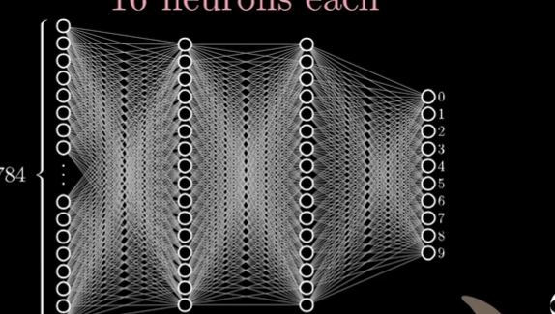 - in practice, there is a lot of room for the structure that needs to be practiced here. We should note fully that the neruaons can be changed accordingly – the numbers can be played around - the end row just represents the 1-10 digit that the network thinks is most likely to start off with

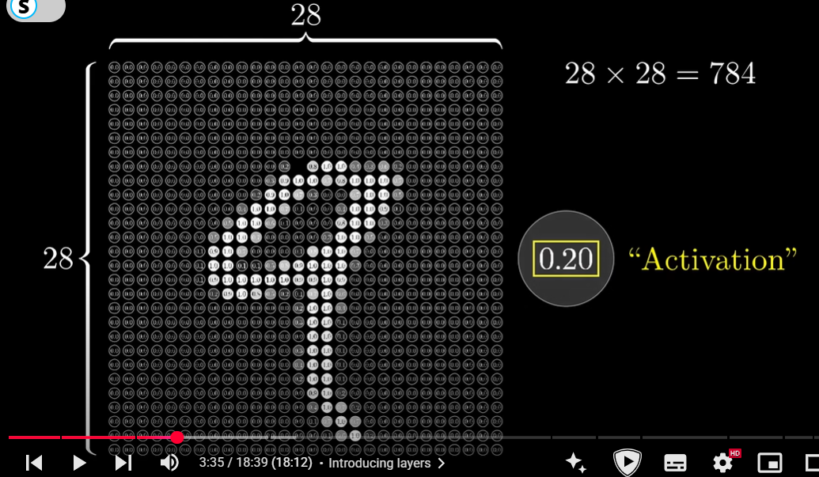 - we are dividing it into a factor of neurons, holding a value

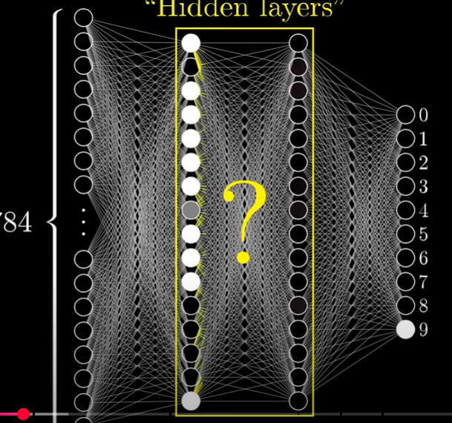 - like a brain’s network, which causes it to fire according to the next layer, and the layer after that - fire very specific neurons accordingly

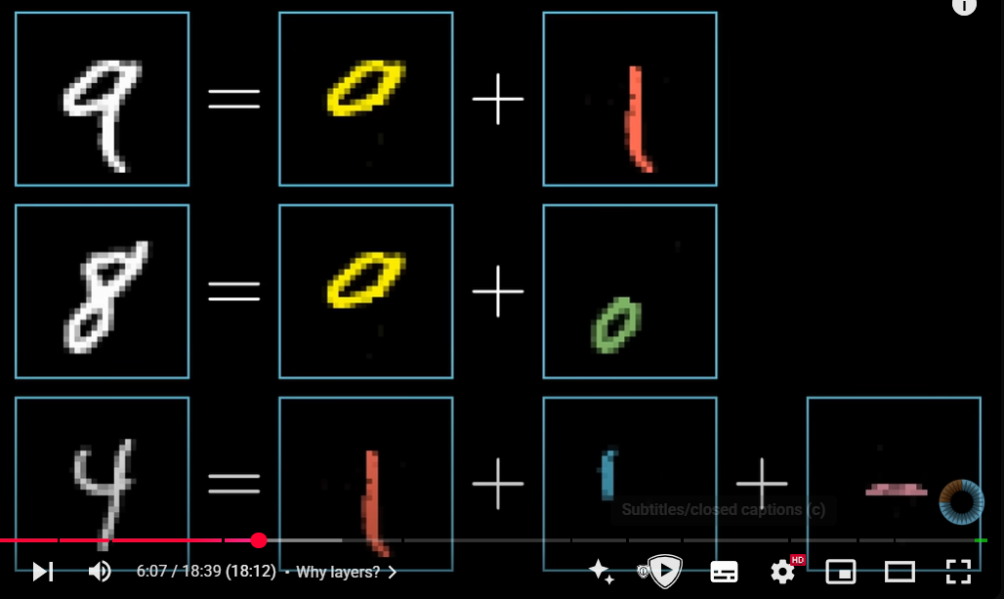
This can be further broken down into:
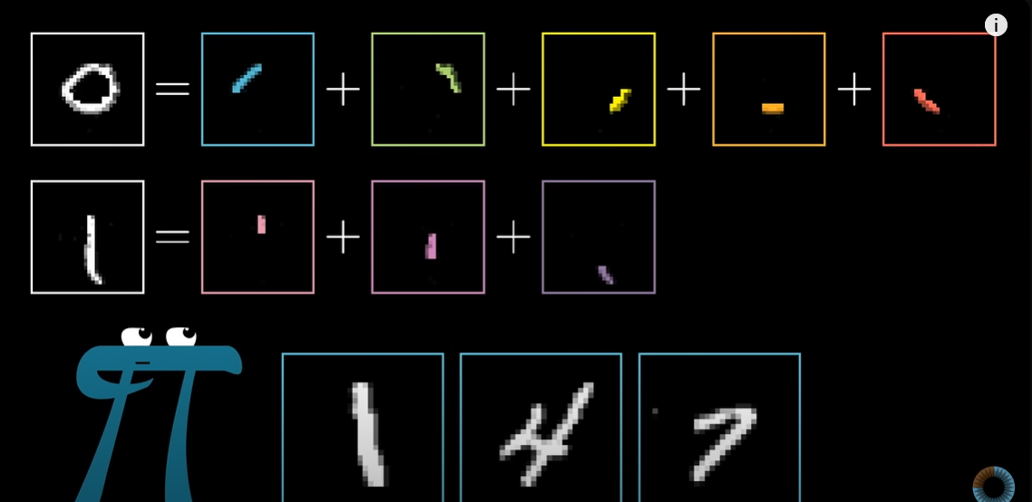

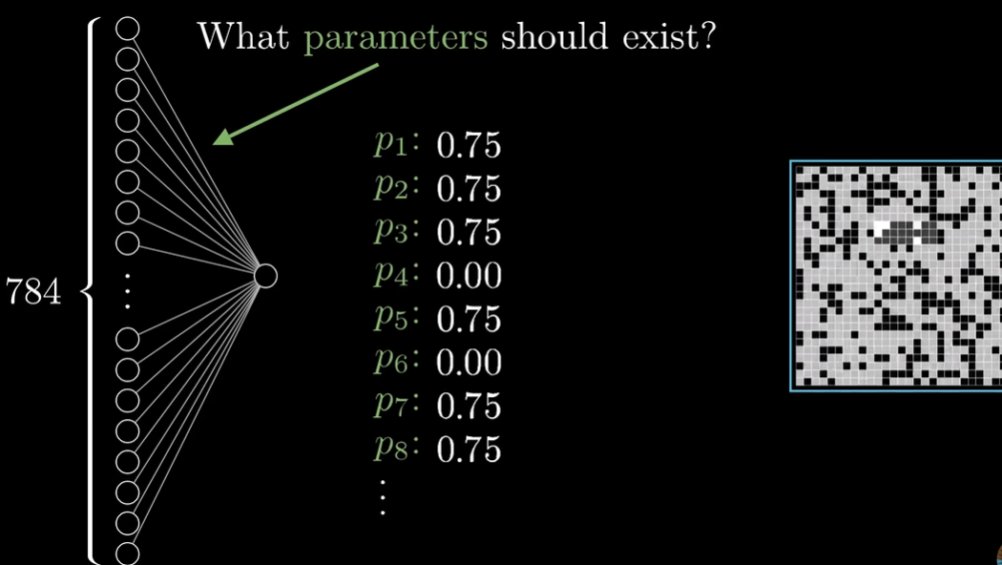 - such that it is able to pick up an edge in the particular position of the image

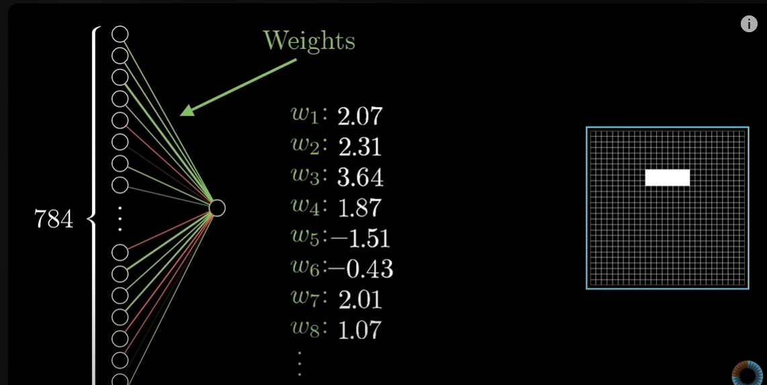 - we assign weights

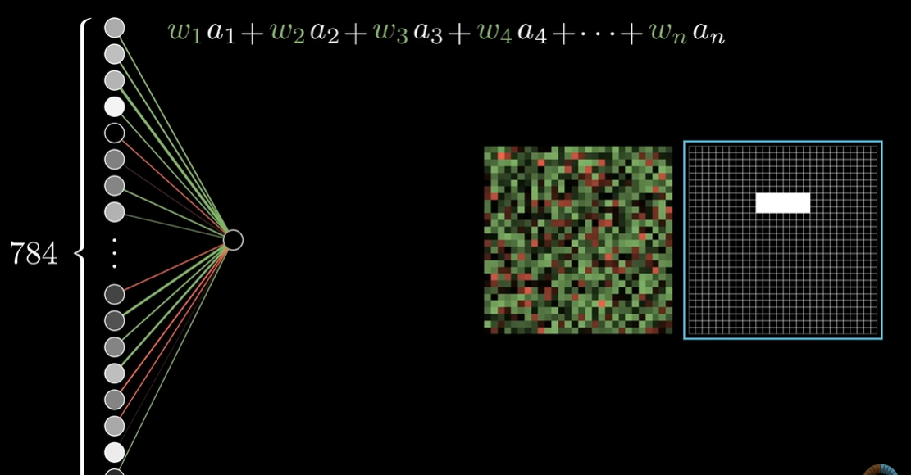 - these weights are distributed accordingly, each weight shows if it’s a positive/negative thing to be addeing up FOR THAT SPECIFIC NODE
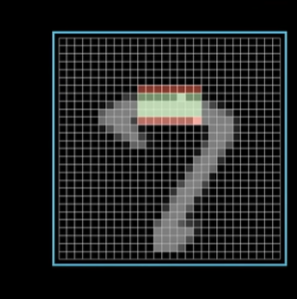 - see this, to see if its an edge, we see around the nodes if they are negative or not – and then checking those pixels which have the popped up colour accordingly.

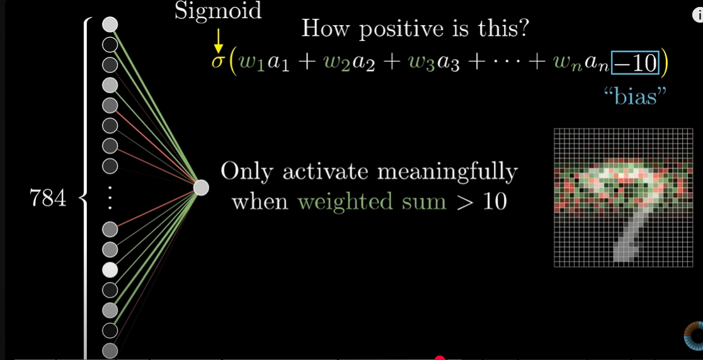 - we want it ot light up only on conditions – the weights tell if you there is a corresponding edge accordingy x

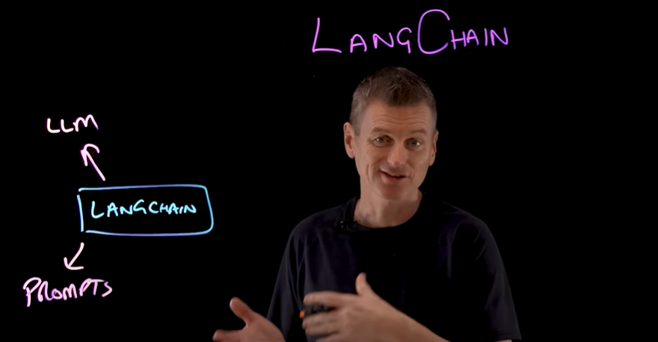 - connects and automates workflow like n8n - create applications by combining a lot of LLMs.

Document loader – vector databases- indices supported by langchain - very open source
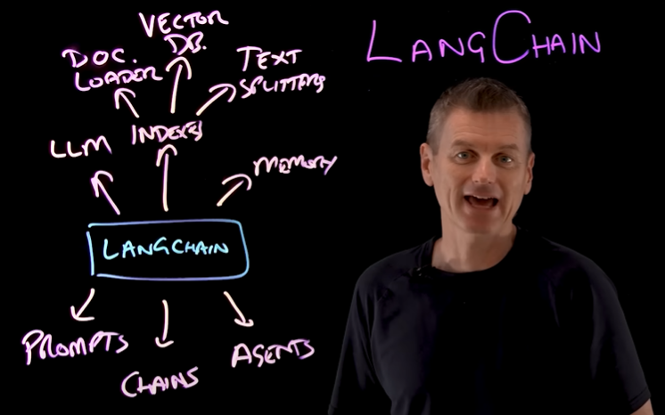 - a lot of features we can use.
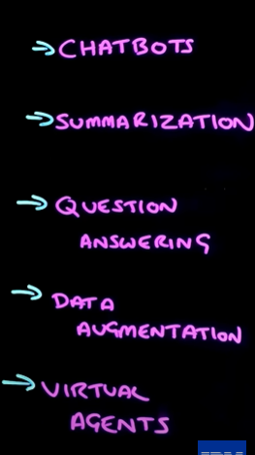 - LLmS AUTONomly detect shit

Langserve- REST API
Langsmith – debug applications

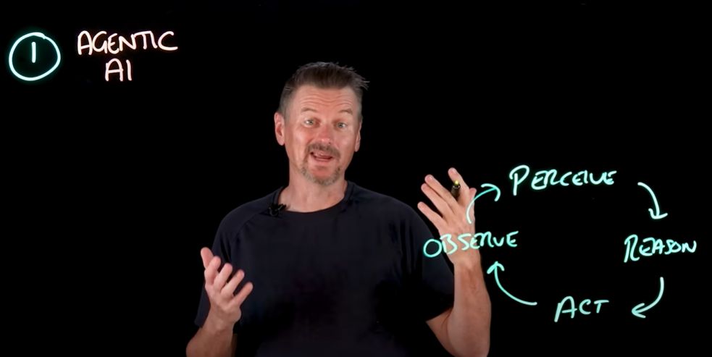

LangChain is an open-source software framework in Python and JavaScript designed to simplify the development of applications powered by large language models (LLMs). It provides a standard interface to connect LLMs with external data sources, tools, and APIs, enabling developers to build applications that integrate with live data and perform complex tasks. LangChain offers a set of reusable components and abstractions, such as Chains and agents, to streamline the process of creating custom, context-aware AI applications like chatbots, document analysis tools, and code analysis systems.

Reasoning models – break down steps by steps – large reasoning chains
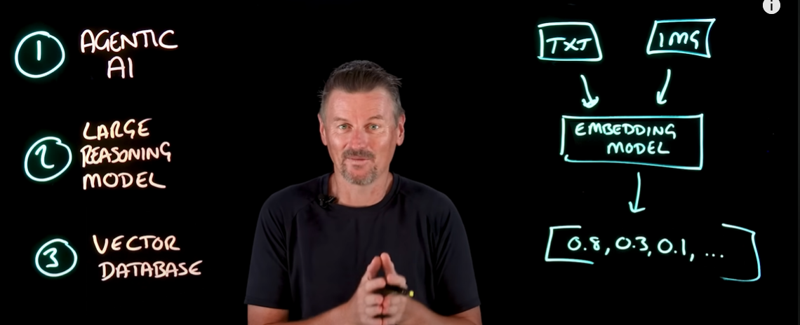

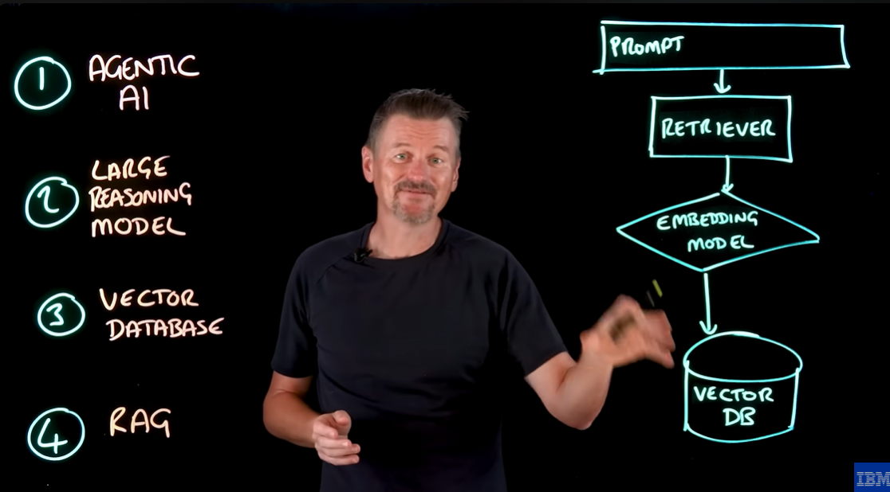 -similarity search in the vector database

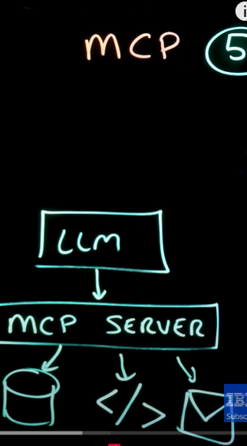 - like API

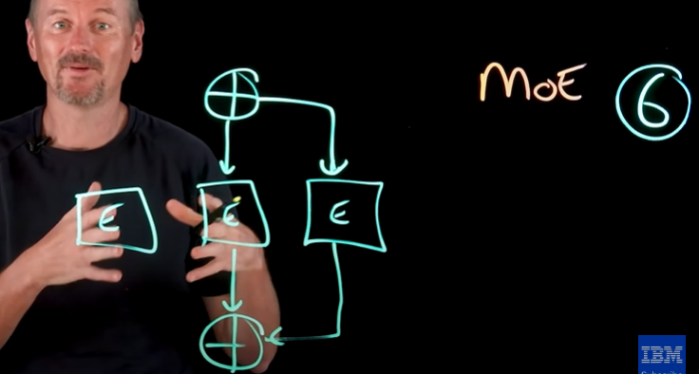 - routing the required agents we needed

https://medium.com/@sudhiryelikar/understanding-similarity-or-semantic-search-and-vector-databases-5f9a5ba98acb

https://www.youtube.com/watch?v=eC6Hd1hFvos

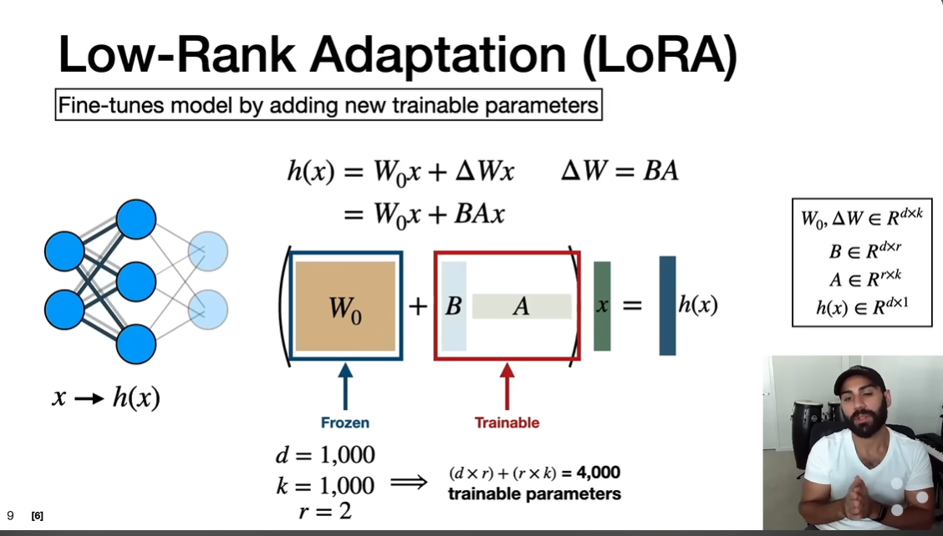 - adding trainable models

